Tableau Lab 2 Answer Sheet

1. The link to your public Tableau dashboard:

https://public.tableau.com/app/profile/jiayu.chen4612/viz/SI649Lab2JiayuChen/Dashboard1

Part I: Phenomenon

“..., both data sets reveal that hate incidents aren’t uniformly distributed across the United States. In other words, a greater number of hate incidents were reported in some states (per 100,000 people) than in others…”

Question 1.1: Visualize **Hate Crimes Per 100K Splc** for each state in the U.S. (2 pts)

***Please replicate the given image using Tableau.***

*Hint: create a new group for* !*is null data or not”.*

*Hint: hide non-null data in the legend.*

*Hint: customize the tooltips using variables.*

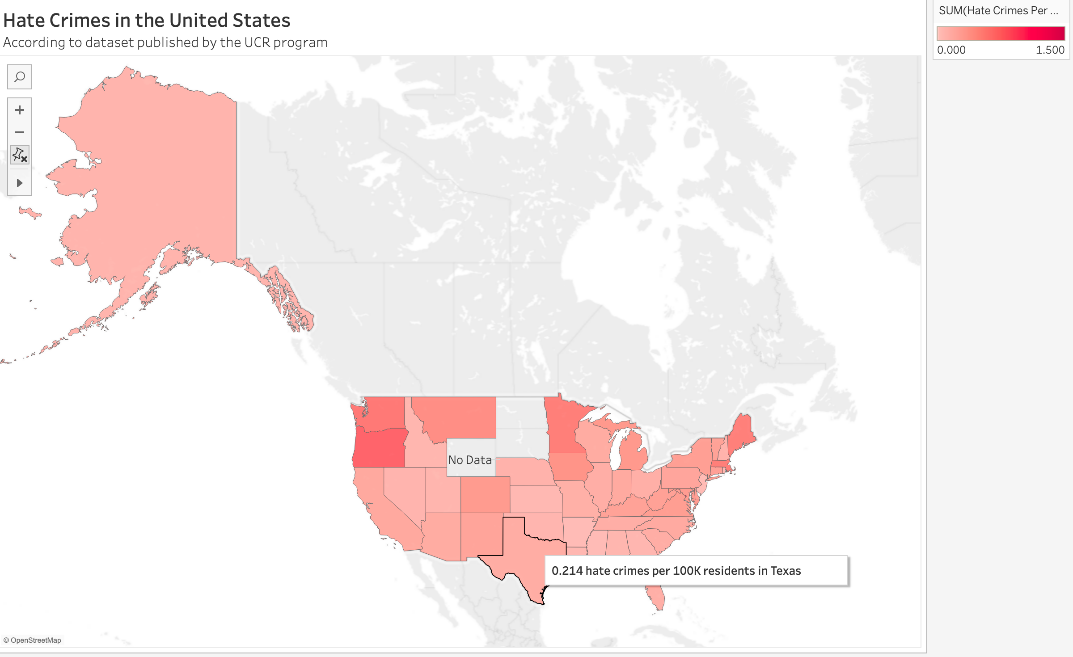

Question 1.2: Add an annotation to the state that has the **highest** number of

Hate Crimes Per 100K Residents. (0.5 pt)

*Hint: create a meaningful and concise description.*

*Hint: include the reason why this data point should draw the audience's attention.*

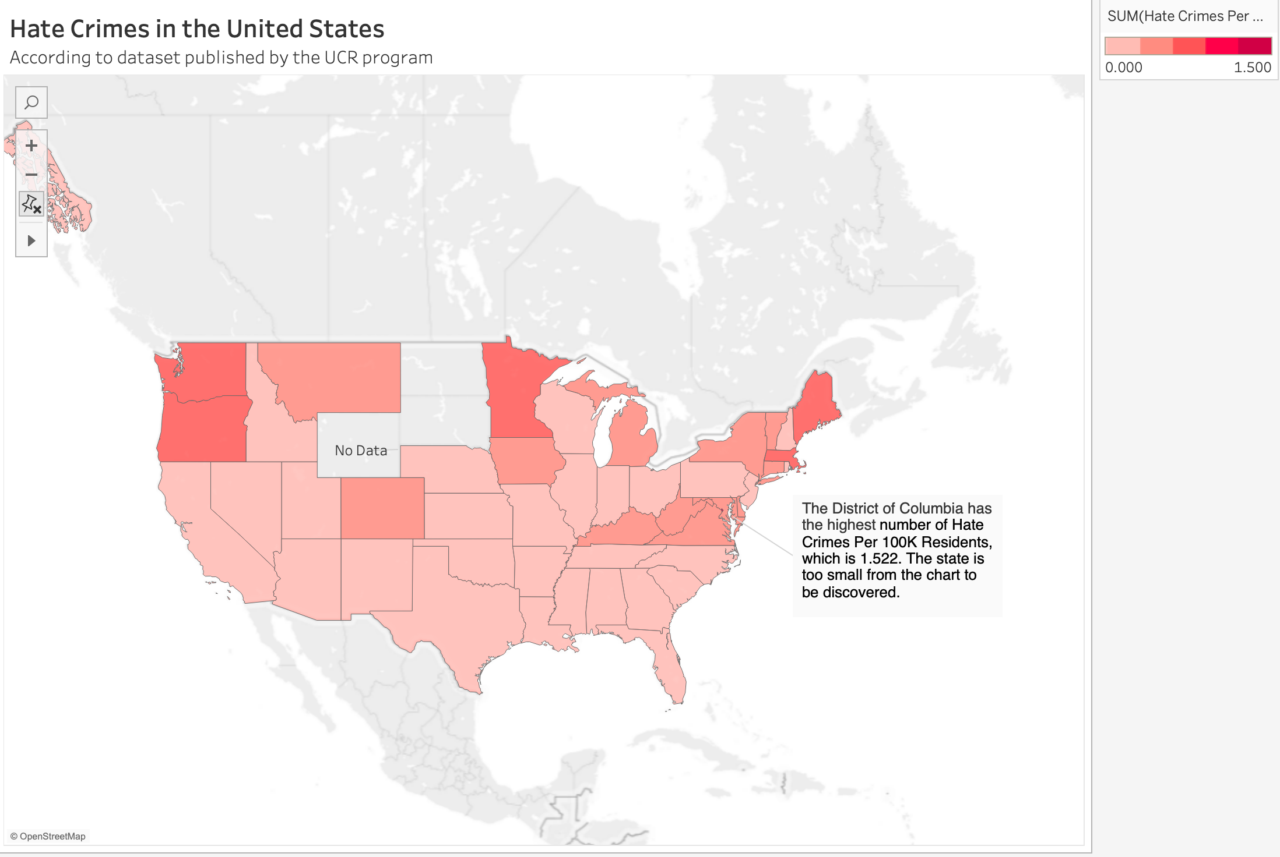

Question 1.3: Explain the **color palette** choice in the sample visualization. How does it compare to a diverging color palette? How does it compare to a non-stepped color palette? (0.5 pt)

The color palette used in the sample visualization is a sequential one, where shades of red are applied in varying intensities, and the intensity increases as the value of hate crimes per 100K residents increases.

Diverging palettes use two contrasting colors on either side of a midpoint to indicate two opposing directions. In this case, since the data ranges from low to high without a clear midpoint or neutral point, a sequential palette is more appropriate than a diverging one.

A non-stepped color palette would display an unbroken transition of colors, representing a continuous range of values. While stepped palette has distinct breaks or steps which are introduced between colors. In this sample, the use of a stepped sequential palette makes it easier to categorize regions into clear bands of hate crime frequency, helping the audience quickly identify high- and low-value areas. While using a non-stepped color palette would make the audience confused when identifying specific regions or thresholds of crime rates.

Part II: Socioeconomic Factors

Question 2.1: Visualize the relationship between **Hate Crimes Per 100K Splc** and the **percent of adults 25 and older with at least a high school degree** for each state in the U.S. using **a linear model**. (0.5 pt)

*Hint: create a scatterplot.*

*Hint: add a trend line using the linear regression model.*

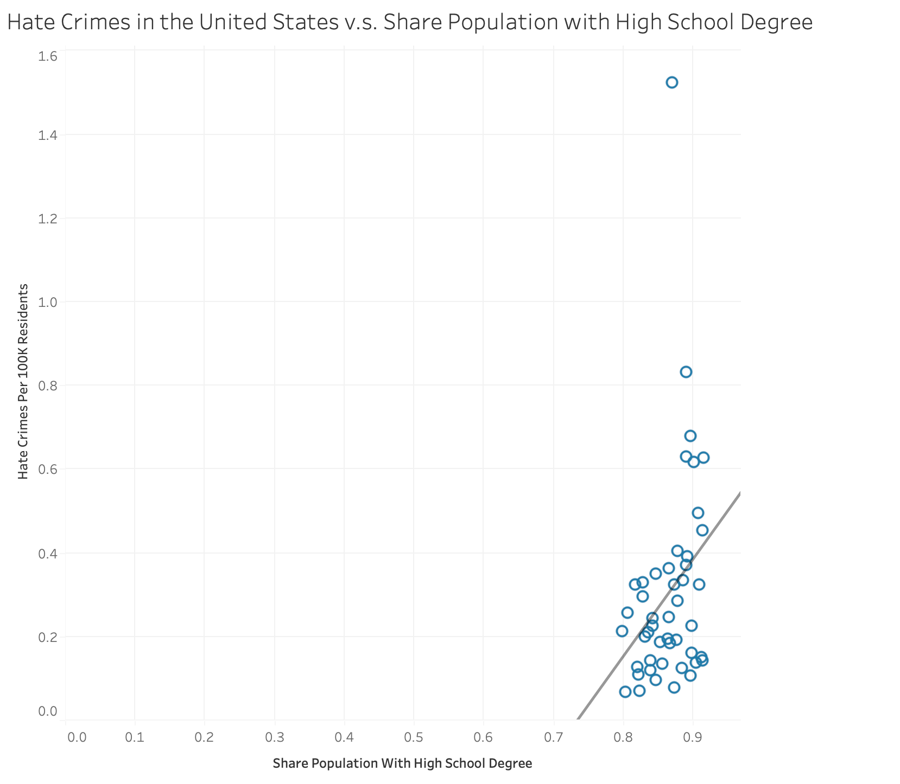

Question 2.2: Is the model significant? Add an appropriate annotation to

demonstrate your answer. (0.5 pt)

*Hint:* ***describe*** *the trend model.*

*Hint: Significance Test for Linear Regression | R Tutorial*

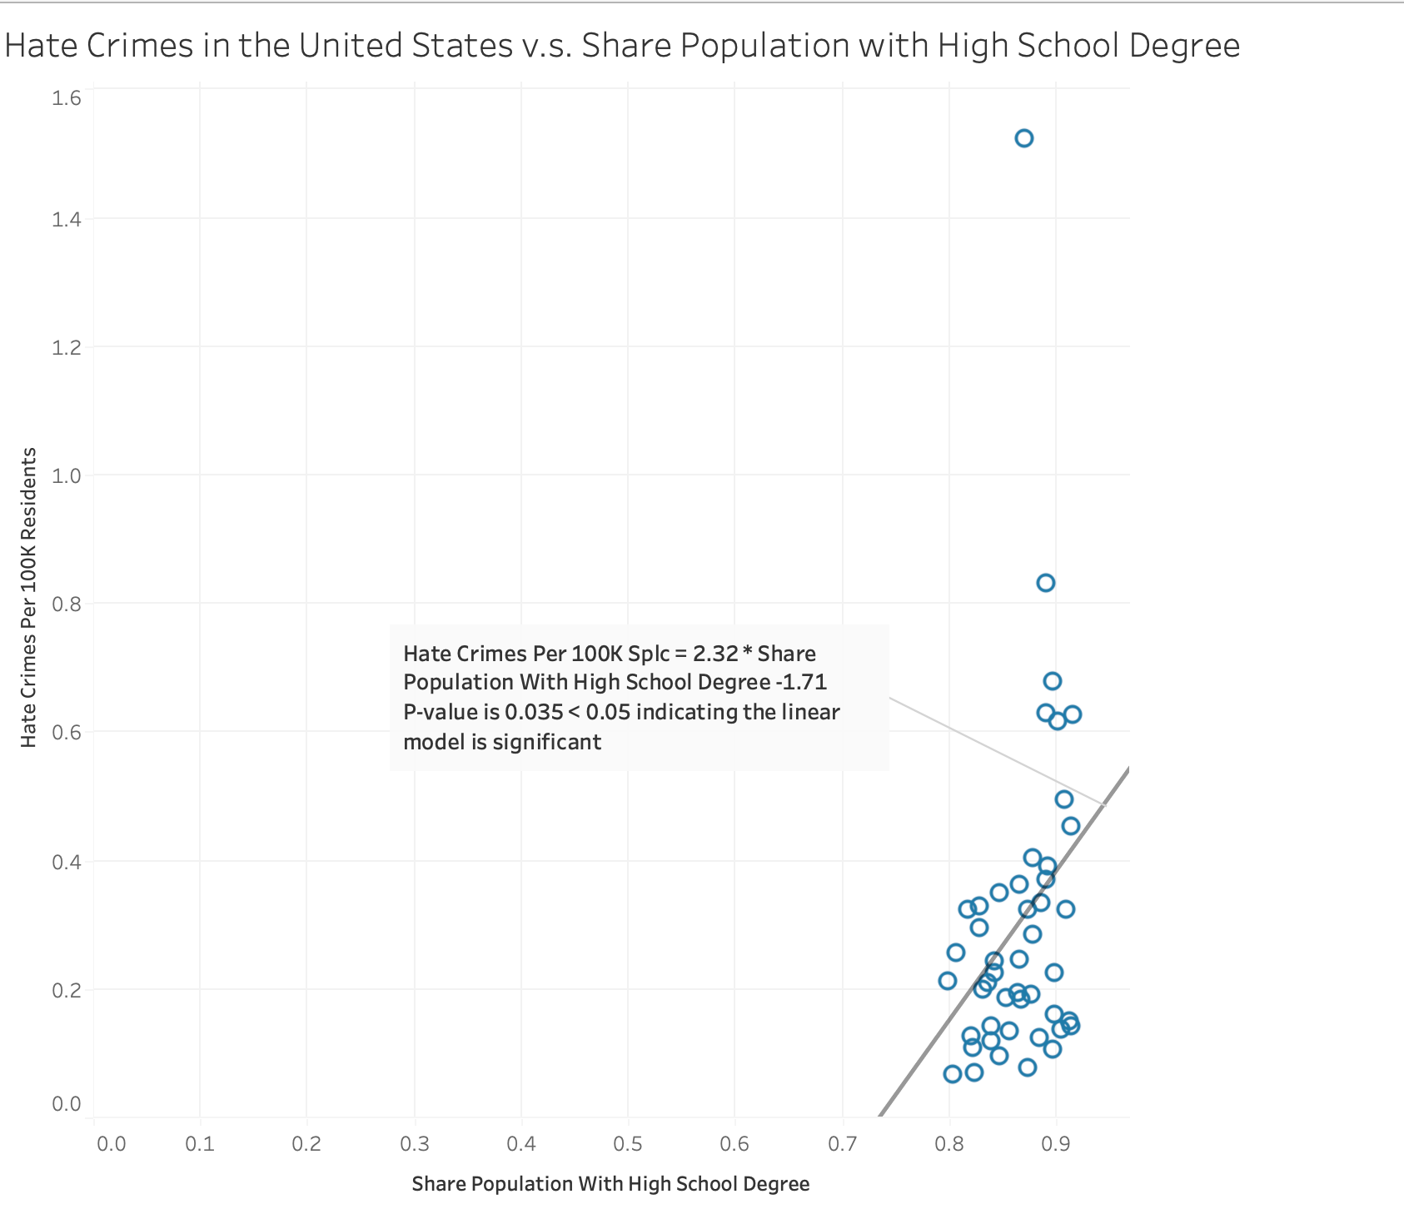

Question 2.3: **Replicate** this sample image in Tableau. How is it different from yours? What are the advantages and disadvantages of the sample? (2 pts)

***Please replicate the given image using Tableau.***

*Hint: select* !*edit all trend lines”*

*Hint: create a new group for* !*District of Columbia”.*

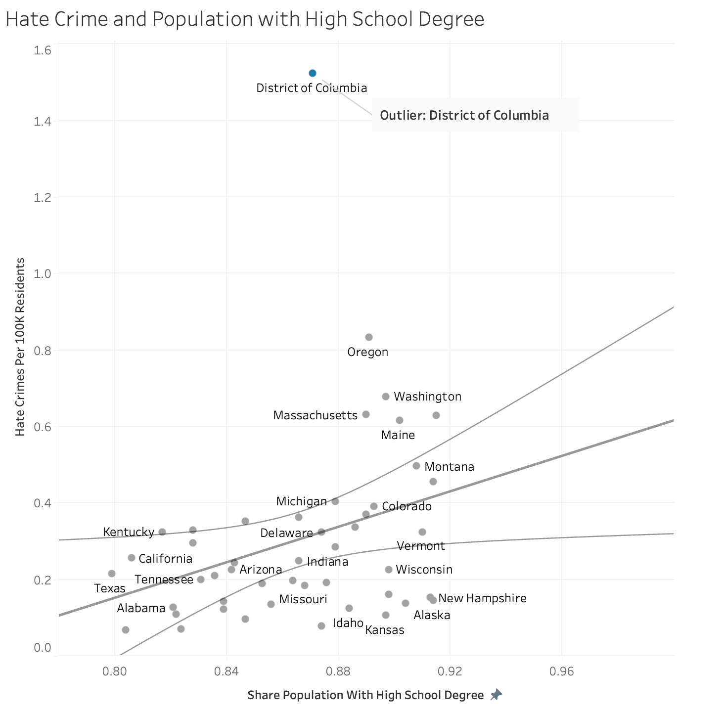

The sample image has confidence intervals for the linear model trend line, more reasonable range of axis, and annotation for outlier. The advantage of the sample is it can show the confidence interval which quantify the uncertainty and provides more context than a point estimate, draw the audience’s attention to the outlier, and visually separate data points which makes it not too crowded. Some states are labeled directly, which helps in understanding specific data points. Its disadvantages may include lack of precision for each data point, and the trend line takes the outlier into account which skews perception.

Part III: Dashboard

Question 3.1: Create a **dashboard** with the two graphs you created for Part I and Part II. (0.5 pt)

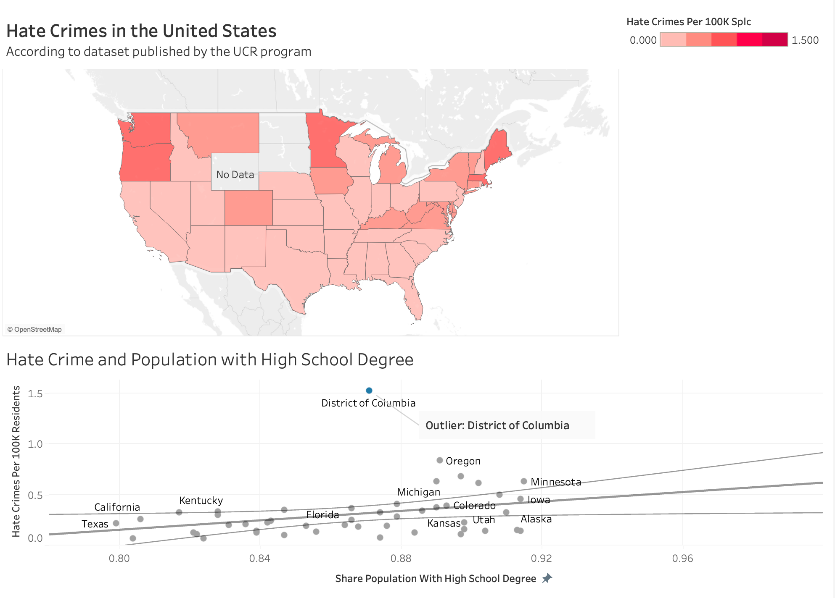

Question 3.2: Create a **highlighter** for *state*. (0.5 pt)

*Hint: creating a highlighter for either graph would work.*

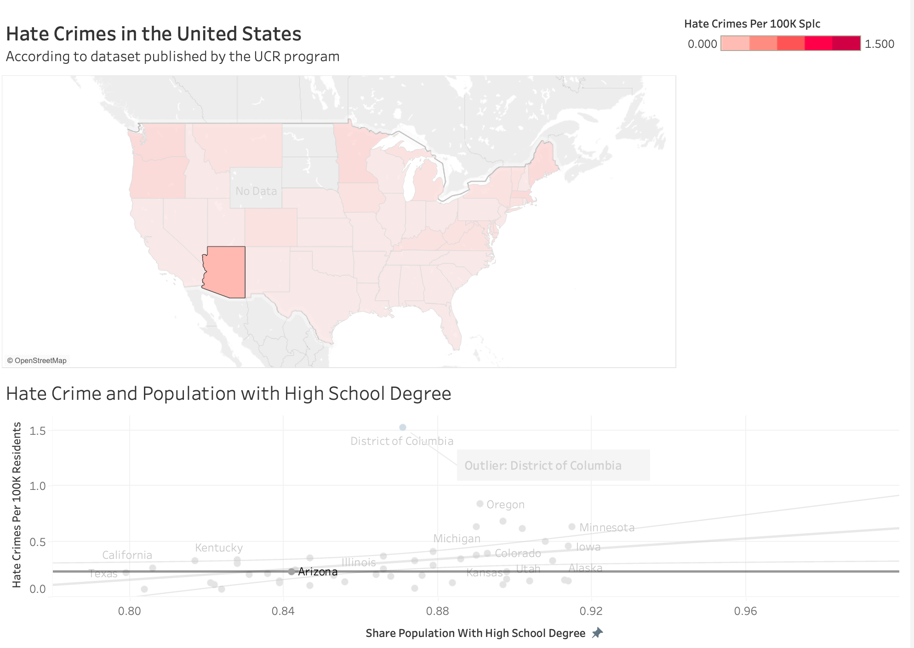

Question 3.3: Create a **highlight action** that would run on **select** and only highlight *state*. (1 pt)

The highlight action should look similar to the example below. (Don"t need to be the same!)

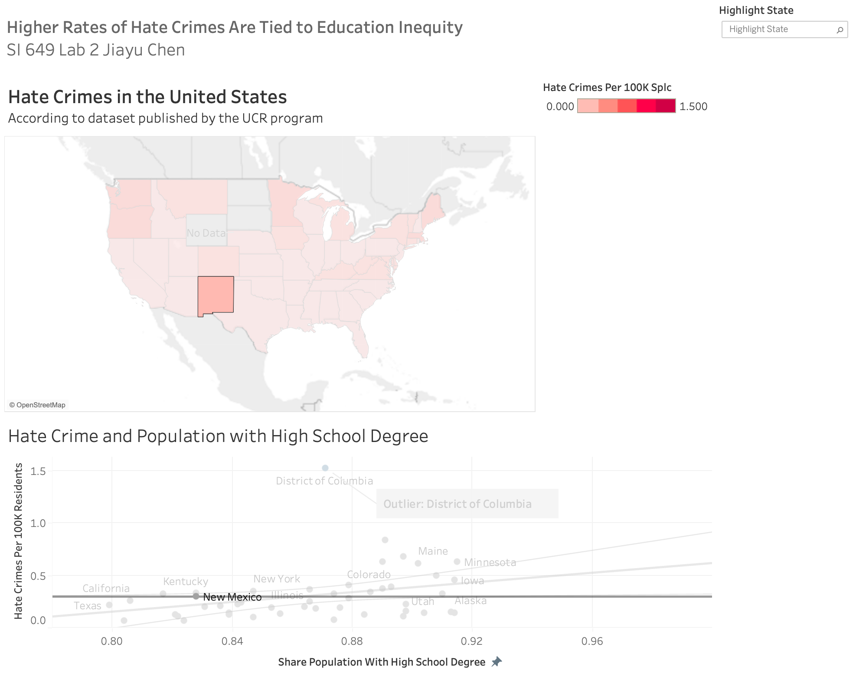

Question 3.4: Refine and upload your dashboard online. (2 + 0.5 pts)

The final dashboard should look similar to the example below. (The layout of the dashboard should be similar to the sample image.)

*Hint: image source: What are the hate crime laws and should they be reformed? - Theos Think Tank*

*Hint: pay attention to the layout of the legend.*

*Hint: think about what needs to be included in the text section (e.g., background, findings,*

*insights, interactions, etc.)*

Bonus: 0.5 pt for reasonable and meaningful text descriptions / aesthetic choices.

